**Apriori Intuition**

* Apriori is all about people who bought something also bought something else, who watched something also watched something else, who did something also did something else, and so on.
* It ,and everything in association rule learning, analyzes when things come in pairs, or combinations for some reason, and look for the rules/ways this happens.
* Let’s take movie recommendation for an example:
* We have the user id, and the movies that they liked
* From here, just by looking at it, without knowing any association rule or apriori algorithm, you can already tell that there are potential rules that can come out of this.
* For instance, it is likely that people who watch movie1, will also like movie2. And people who like movie2, are likely to watch movie4, and so on.

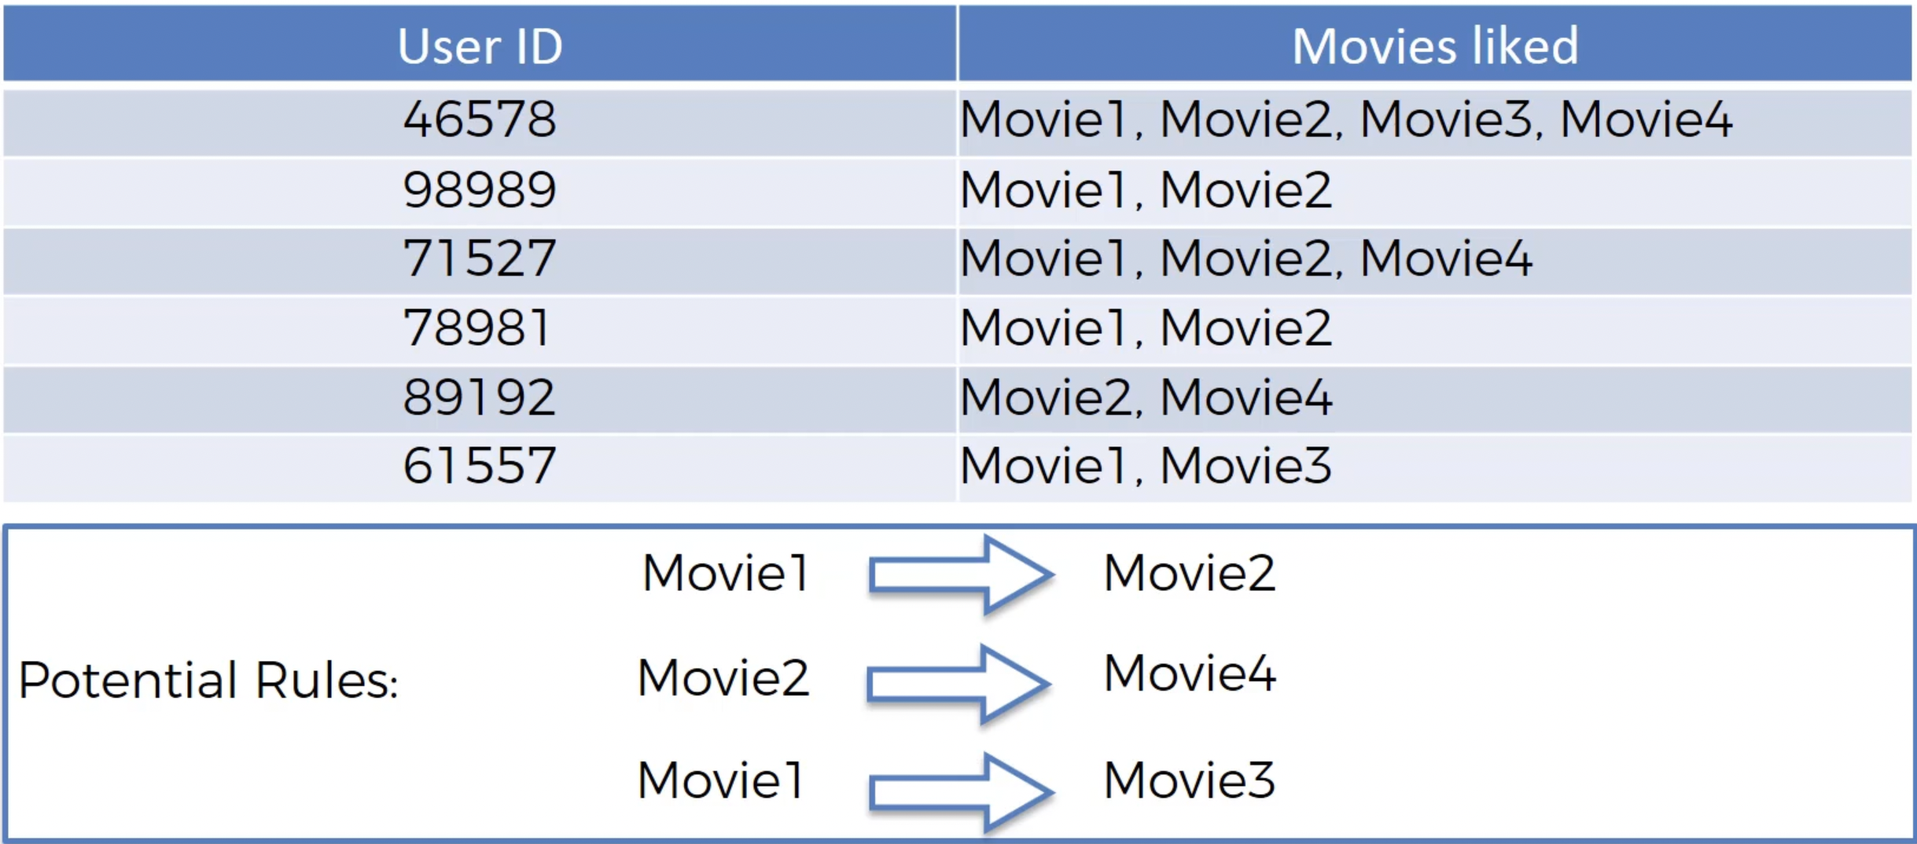

* From looking at the example below, we can say that we can come up with lots of potential rules – some will be stronger, some weaker – and we want to find the strong ones to build our business decisions on the rules we can see in the data.
* Here is another example for the same:

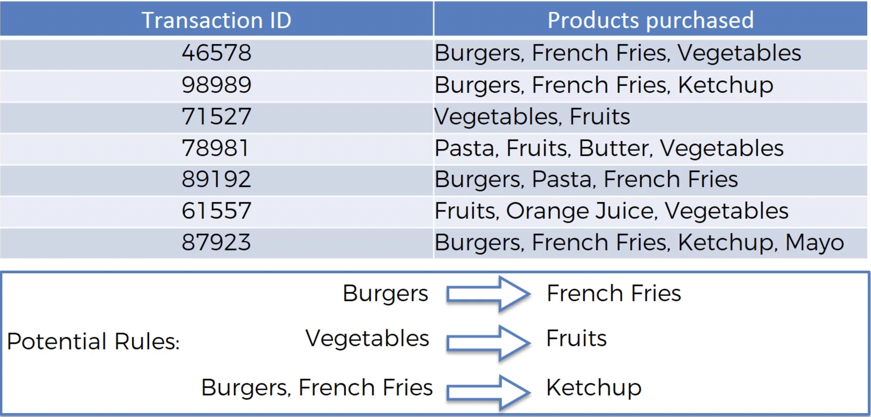

**Working of Apriori Algorithm** –

* The Apriori Algorithm has three parts: -

1. Support
2. Confidence
3. Lift

1. **Support** –

* Support part is very similar to the Bayesian classifiers.
* Let’s take the movie recommendation example once again –

Support for Movie(M) is defined as the number of users who watched Movie(M) divided by the total number of users.

$$support\left(M\right)=\frac{\#user watchlist containing M}{\#user watchlists}$$

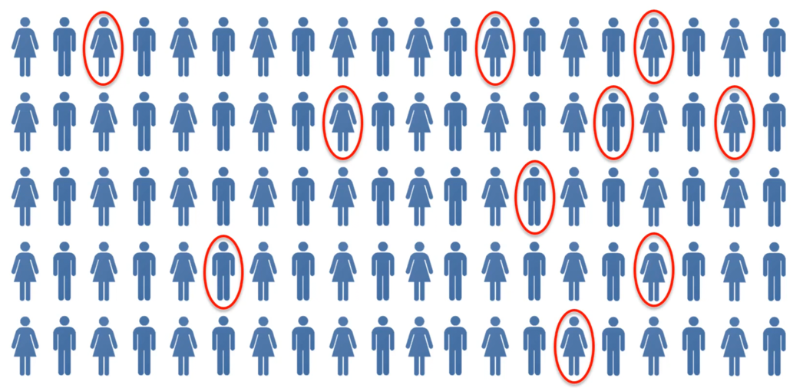

* Above, we have a population of 100, and 10 of them have seen Ex-Machina.
* Thus, our support would be 10/100 = 10%.
* And for the Market Basket Optimization, Support for Item (I) is defined as total number of transactions containing *I* divided by total number of transactions.

$$support\left(I\right)=\frac{\#transactions containing I}{\#transactions}$$

1. **Confidence** –

* Confidence is defined as, let’s say movie for example, the number people who have seen movies M1 and M2 divided by the number of people who have seen movie M1.
$$confidence\left(M1→M2\right)=\frac{\#user watchlist containing M1 and M2}{\#user watchlists containing M1}$$

* Here, we are going to assume that we are testing a rule that, let’s say movie Interstellar – we have a hypothesis that people who have seen/liked Interstellar are also likely to have seen Ex-Machina.
* So, in our example Movie M1 is going to be Interstellar, and we are going to check everyone who has seen Ex-Machina.
* In the numerator we will have people who have seen Interstellar and Ex-Machina, in the denominator we will have people who have seen Interstellar.

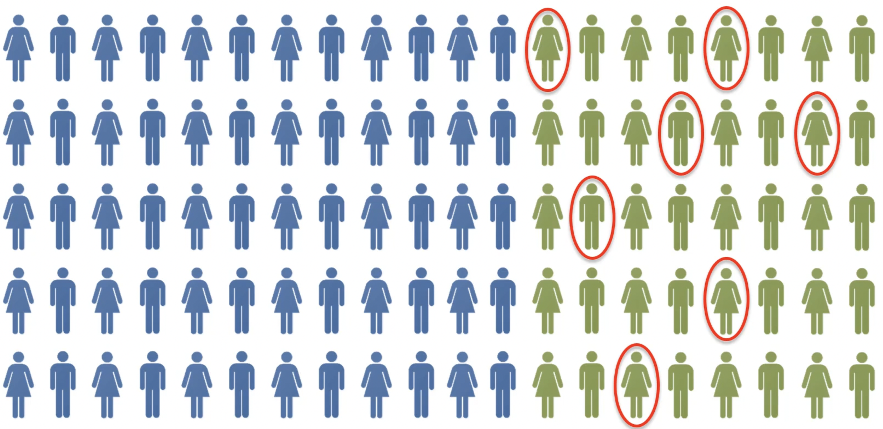

* Above, we have people in green (40) from our population who have seen Interstellar, and the ones circled in red (7) are the ones who have seen Ex-Machina too.
* Thus, our confidence would be 7/40 = 17.5%.
$$confidence\left(I1→I2\right)=\frac{\#transactions containing I1 and I2}{\#transaction containing I1}$$

* And for market transaction we are doing the same thing – French fries and burgers for instance. In the numerator you will have people who have ordered burger and French fries, and in the denominator, you will have people who have ordered burgers.

1. **Lift –**

* Lift is going to be very similar to what we had in Naïve Bayesian classifier – it is basically Confidence divided by Support

$$lift\left(M1→M2\right)=\frac{confidence(M1→M2)}{support(M1)}$$

$$lift\left(M1→M2\right)=\frac{confidence(M1→M2)}{support(M1)}$$

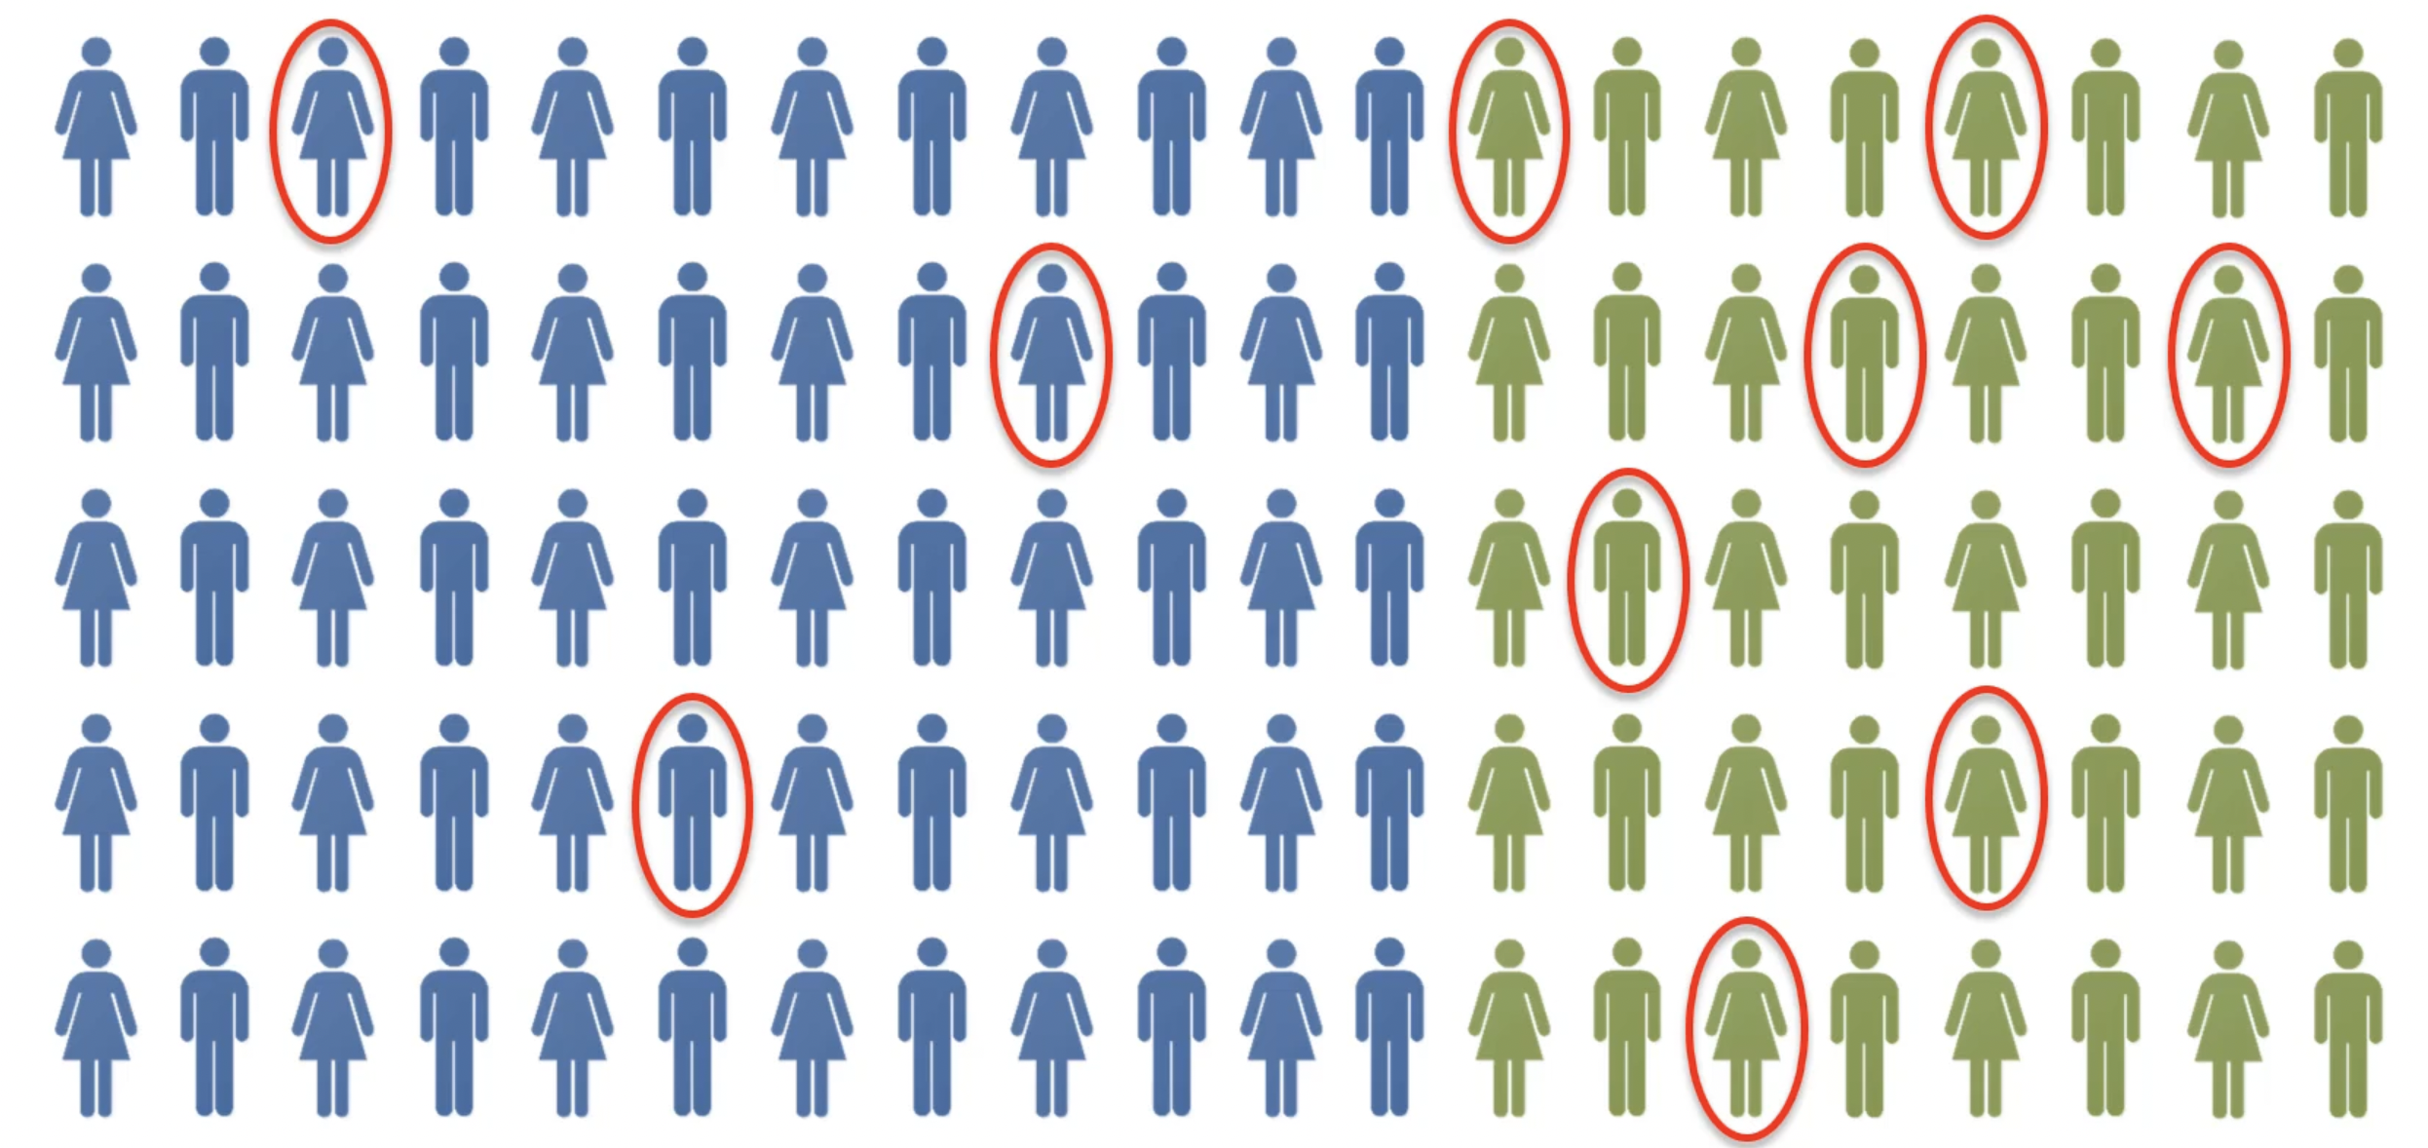

* Let’s say people in green have watched/liked Interstellar, and everyone circled in red have watched/liked Ex-Machina.
* So, if we just randomly suggest to a person to watch Ex-Machine, what is the likelihood, not in this population, that they will watch/like it.
* Mathematically speaking, the probability of them watching/enjoying is 10% (there are 100 people in our given population, and only 10 have watched/liked Ex-Machina).
* But the question here is, can we prove that result by using some prior knowledge?

YES! In that new population we only recommend Ex-Machine only to the people who have seen Interstellar (the green people in our population).

In that case, from the green people in our population (watched Interstellar), 17.5% watched/enjoyed Ex-Machina.

* So, lift is the improvement in the original prediction. If we pick people from our original population, likelihood of people watching Ex-Machina is 10%, but if we recommend it to people who have seen Interstellar, it goes up by 7.5% i.e., 17.5%.
* So, in our case, lift if 1.75%.

**Apriori – Algorithm**:

**Step 1** – Set a minimum support and confidence. Because there are so many different

recommendations, we only looked at one example with two movies to simplify things.

There could be 100s of different movies, and their different combinations. As each combination could be a set of multiple items, it gets quite big, and we need to set some limitations and hence, we need to set a limitation for minimum support. For instance, we might not want to consider at items that have support less than 20%, or even 5% as we won’t want to build a model with an item that has its own support of less than 20% or 5%. And same for confidence, we don’t want to consider something less than 12% or 20%.

**Step 2** – Take all the subsets in transactions having higher support than minimum support. Here, we take all the subsets that exceed the level of minimum support set in step 1.

**Step 3** – Take all the rules of these subsets having higher confidence than minimum confidence. Here, we take all the subsets that exceed the level of minimum confidence set in step 1.

**Step 4** – Sort the rules by descending lift.

Here, we sort the rules in a decreasing order of the lift. The rule with the highest lift, given that above criteria (step 1 to step 3) are satisfied, is going to be the strongest rule, and that’s the one we would look into first.

Note - Apriori is kind of a slow algorithm because it goes through the different combinations.

We can also consider the example of Amazon, or Netflix to understand the concept of Apriori, but they use much more sophisticated, or even combinations of multiple algorithms, and sometimes even tailored fit algorithms for their requirements.